EXPERIMENT 8
TITLE: READING AN IMAGE IN PYTHON AND DILATING AN IMAGE USING THE DILATE FUNCTION
AIM
To read an image using Python and OpenCV and perform dilation using the cv2.dilate() function.
SOFTWARE REQUIREMENTS
- Python
- OpenCV library
- NumPy library
- Notepad
- Input image (flower.jpg)
PROCEDURE
- Open Notepad and write the Python program.
- Save the program as experiment8_dilation.py in the opencv folder.
- Place the input image flower.jpg in the same folder.
- Import the OpenCV and NumPy libraries.
- Read the image using the cv2.imread() function.
- Create a 5 × 5 kernel using NumPy.
- Apply dilation using the cv2.dilate() function.
- Display the original and dilated images using the cv2.imshow() function.
- Save the dilated image as dilated_flower.jpg using the cv2.imwrite() function.
- Execute the program and observe the output.
PROGRAM
import cv2
import numpy as np
img = cv2.imread("flower.jpg")
if img is None:
print("Image not found!")
else:
kernel = np.ones((5, 5), np.uint8)
dilated = cv2.dilate(img, kernel, iterations=1)

cv2.imshow("Original Image", img)
cv2.imshow("Dilated Image", dilated)

cv2.imwrite("dilated_flower.jpg", dilated)

cv2.waitKey(0)
cv2.destroyAllWindows()

print("Dilated image saved successfully!")
OUTPUT
The original flower image and the dilated image are displayed in separate windows. The processed image is saved as dilated_flower.jpg.
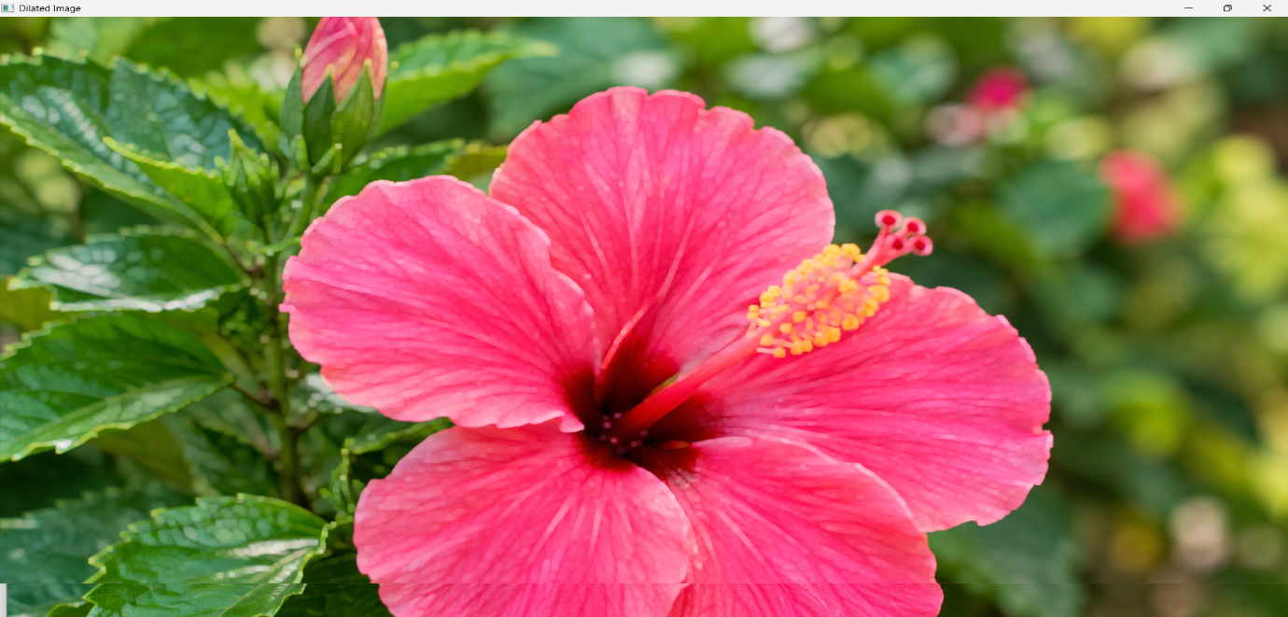
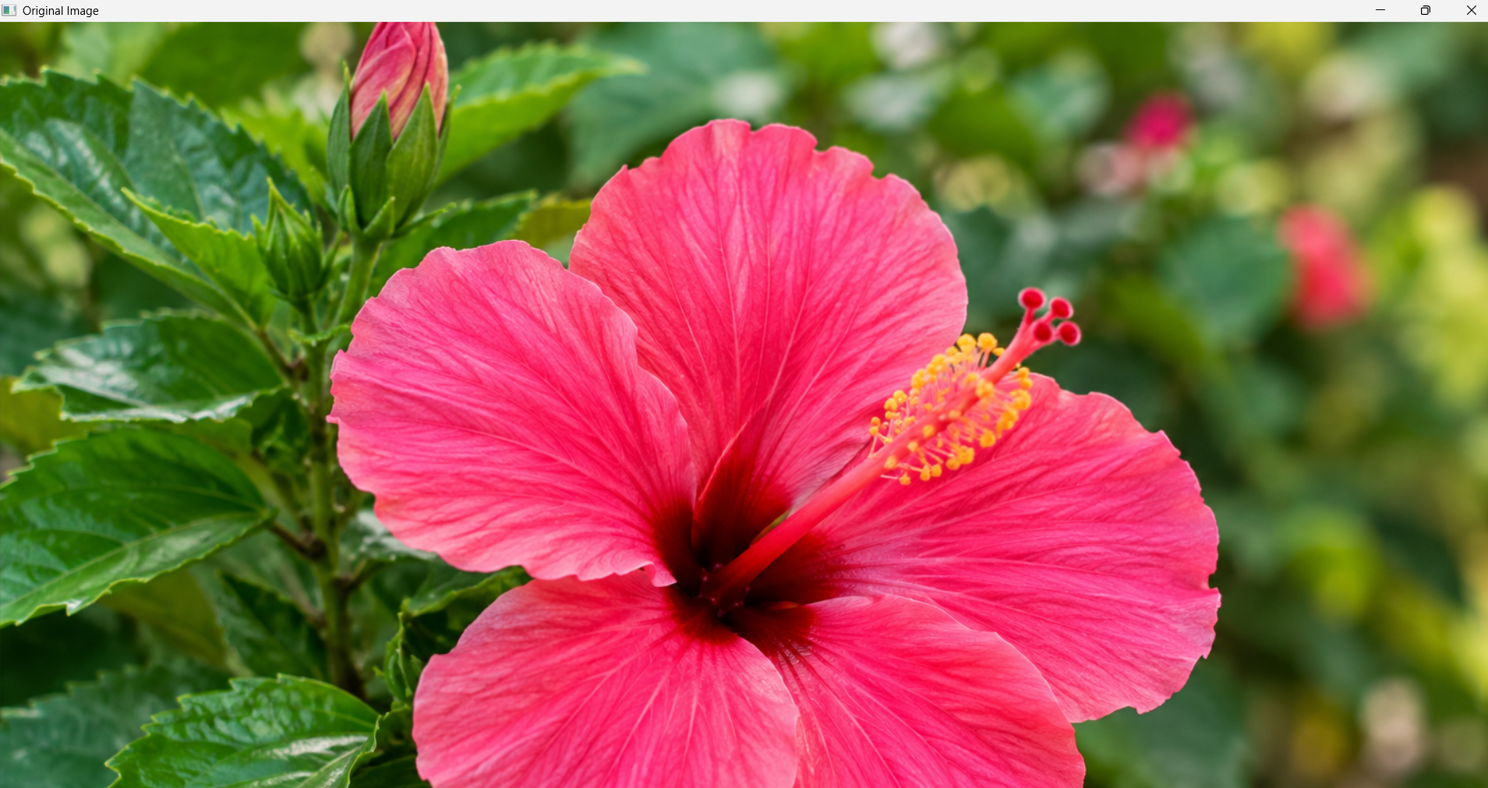
RESULT
Thus, the input image was successfully read using Python and OpenCV, and dilation was performed using the cv2.dilate() function.

